**Create a new react application using *create-react-app* tool with the name as “blogapp”**

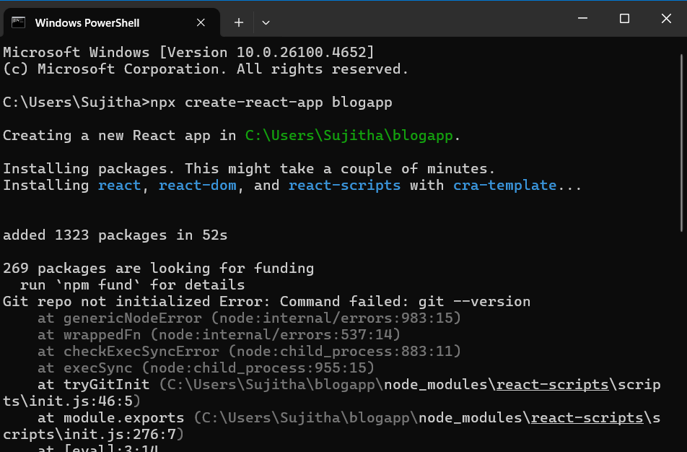

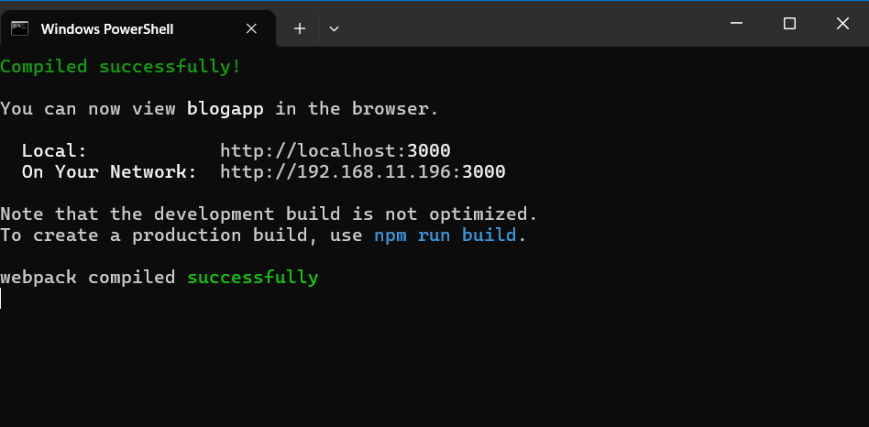

Post.js

import React, { Component } from "react";

class Post extends Component {

    render() {

        return (

            <div>

                <h2>{this.props.title}</h2>

                <p>{this.props.body}</p>

            </div>

        );

    }

}

export default Post;

Posts.js

import React, { Component } from "react";

import Post from "./Post";

class Posts extends Component {

    constructor() {

        super();

        this.state = {

            posts: []

        };

    }

    loadPosts() {

        fetch("https://jsonplaceholder.typicode.com/posts")

            .then(response => response.json())

            .then(data => {

                this.setState({ posts: data });

            });

    }

    componentDidMount() {

        this.loadPosts();

    }

    componentDidCatch(error, info) {

        alert("Error occurred: " + error);

    }

    render() {

        return (

            <div>

                {this.state.posts.map(post => (

                    <Post key={post.id} title={post.title} body={post.body} />

                ))}

            </div>

        );

    }

}

export default Posts;

App.js

// App.js

import React from "react";

import Posts from "./Posts";

function App() {

    return (

        <div className="App">

            <h1>Blog Posts</h1>

            <Posts />

        </div>

    );

}

export default App;

Output

